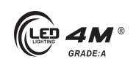LED Integrated Testing System test report

test item: | LED spectrum analyse
equipment: | Led test system
设备厂商获得证书： | 国家半导体工程研发及产业联盟证书，中国光学光电子行业协会光电器件分会证书，高新技术企业证书
 | Mode:MB 010 NRA 20061010 6000K | Manufacturer:
Test Identifier | Temperature:25℃ | Humidity:60%
Test Identifier | Conner: | Date:2017.10
 | Organ:
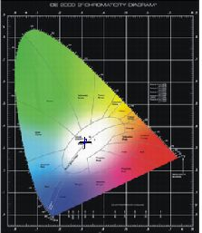
curve of spectrum power distributing
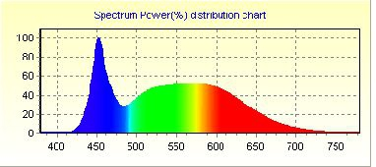

Spectrum |  |  | Electrical
λ(Peak): | 451.8 | nm | I(test): | 94.000 mA
λ(Main): | 488.9 | nm | Vf: | 220.200 V
λ(Centroid): | 0.0 nm |  | φv: | 737.98 lm
λ(Center): | 0.0 nm |  | Efficiency: | 72.351 lm/w
BandWidth: | 25.8 | nm | P: | 10.2 W
ColorTemp: | 6272 | K | PFC: | 0.493
CIE(x,y): | 0.3115, 0.3285 |  | Ra1:82.4 | Ra2:89.5 | Ra3:93.7
CIE(u,v): | 0.1972, 0.3119 |  | Ra4:83.9 | Ra5:83.6 | Ra6:84.8
[[
Ra: | 84.3 |  | Ra7:86.9 | Ra8:69.5 | Ra9:12.7
Purity: | 0.077 |  | Ra10:74.5 | Ra11:85.2 | Ra12:57.1
Light Power: | 1204.1921 mw |  | Ra13:84.2 | Ra14:96.8 | Ra15:77.3

Remark:

page 1 of 1 2017-10-10 15:37:14

