LED Integrated Testing System test report

test item: | LED spectrum analyse
equipment: | Led test system
设备厂商获得证书： | 国家半导体工程研发及产业联盟证书，中国光学光电子行业协会光电器件分会证书，高新技术企业证书
 | Mode:MB 016 NRA 20061016 6000K | Manufacturer:
Test Identifier | Temperature:25℃ | Humidity:60%
Test Identifier | Conner: | Date:2017.01
 | Organ:
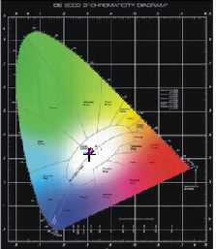
curve of spectrum power distributing
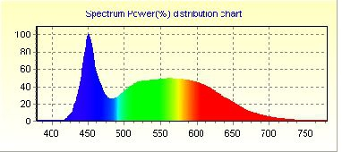

Spectrum |  |  | Electrical
λ(Peak): | 450.7 | nm | I(test): | 145.000 mA
λ(Main): | 485.2 | nm | Vf: | 220.300 V
λ(Centroid): | 0.0 nm |  | φv: | 1232.58 lm
λ(Center): | 0.0 nm |  | Efficiency: | 74.702 lm/w
BandWidth: | 24.7 | nm | P: | 16.5 W
ColorTemp: | 6214 | K | PFC: | 0.516
CIE(x,y): | 0.3070, 0.3204 |  | Ra1:84.1 | Ra2:89.1 | Ra3:91.7
CIE(u,v): | 0.1971, 0.3085 |  | Ra4:86.0 | Ra5:84.8 | Ra6:83.6
Ra: | 84.9 |  | Ra7:87.3 | Ra8:72.6 | Ra9:18.5
Purity: | 0.099 |  | Ra10:73.1 | Ra11:86.7 | Ra12:59.4
Light Power: | 2701.0037 mw |  | Ra13:85.2 | Ra14:95.6 | Ra15:79.7

Remark:

page 1 of 1 2016-11-10 15:58:37

