LED Integrated Testing System test report

test item: | LED spectrum analyse
equipment: | Led test system
设备厂商获得证书： | 国家半导体工程研发及产业联盟证书，中国光学光电子行业协会光电器件分会证书，高新技术企业证书
 | Mode:MB 025 NRA 20061025 6000K | Manufacturer:
Test Identifier | Temperature:25℃ | Humidity:60%
Test Identifier | Conner: | Date:2017.01
 | Organ:
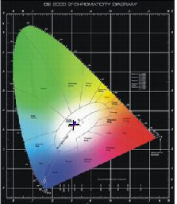
curve of spectrum power distributing
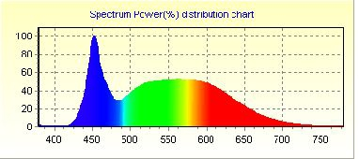

Spectrum |  |  | Electrical
λ(Peak): | 451.8 | nm | I(test): | 211.000 mA
λ(Main): | 489.3 | nm | Vf: | 220.200 V
λ(Centroid): | 0.0 nm |  | φv: | 1908.75 lm
λ(Center): | 0.0 nm |  | Efficiency: | 75.148 lm/w
BandWidth: | 25.8 | nm | P: | 25.4 W
ColorTemp: | 6258 | K | PFC: | 0.524
CIE(x,y): | 0.3101, 0.3290 |  | Ra1:82.1 | Ra2:89.3 | Ra3:93.7
CIE(u,v): | 0.1960, 0.3120 |  | Ra4:83.7 | Ra5:83.4 | Ra6:85.0
Ra: | 84.2 |  | Ra7:87.2 | Ra8:69.5 | Ra9:11.9
Purity: | 0.082 |  | Ra10:74.1 | Ra11:85.5 | Ra12:57.0
Light Power: | 4713.3218 mw |  | Ra13:83.9 | Ra14:96.8 | Ra15:76.8

Remark:

page 1 of 1 2016-11-10 16:03:01

