LED Integrated Testing System test report

test item: | LED spectrum analyse
equipment: | Led test system
设备厂商获得证书： | 国家半导体工程研发及产业联盟证书，中国光学光电子行业协会光电器件分会证书，高新技术企业证书
 | Mode:MB 042 NRA 20061042 6000K | Manufacturer:
Test Identifier | Temperature:25℃ | Humidity:60%
Test Identifier | Conner: | Date:2017.01
 | Organ:
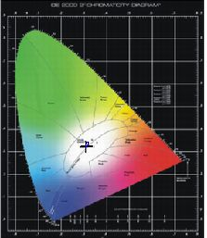
curve of spectrum power distributing
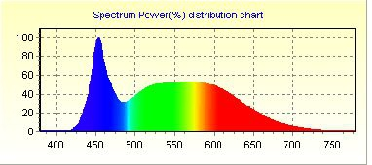

Spectrum |  |  | Electrical
λ(Peak): | 453.3 | nm | I(test): | 333.000 mA
λ(Main): | 488.7 | nm | Vf: | 220.100 V
λ(Centroid): | 0.0 nm |  | φv: | 3413.09 lm
λ(Center): | 0.0 nm |  | Efficiency: | 79.932 lm/w
BandWidth: | 27.3 | nm | P: | 42.7 W
ColorTemp: | 6334 | K | PFC: | 0.535
CIE(x,y): | 0.3088, 0.3276 |  | Ra1:82.7 | Ra2:90.3 | Ra3:94.5
CIE(u,v): | 0.1956, 0.3113 |  | Ra4:83.4 | Ra5:83.7 | Ra6:85.8
Ra: | 84.7 |  | Ra7:87.2 | Ra8:69.7 | Ra9:13.8
Purity: | 0.087 |  | Ra10:76.3 | Ra11:85.1 | Ra12:57.4
Light Power: | 7841.3048 mw |  | Ra13:84.7 | Ra14:97.3 | Ra15:77.4

Remark:

page 1 of 1 2016-11-10 16:31:39

